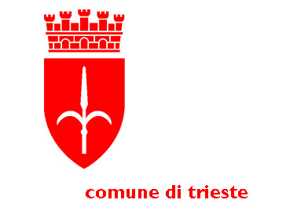
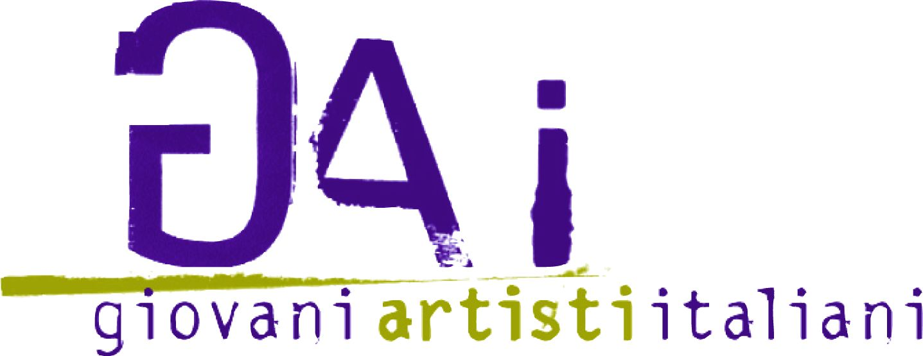
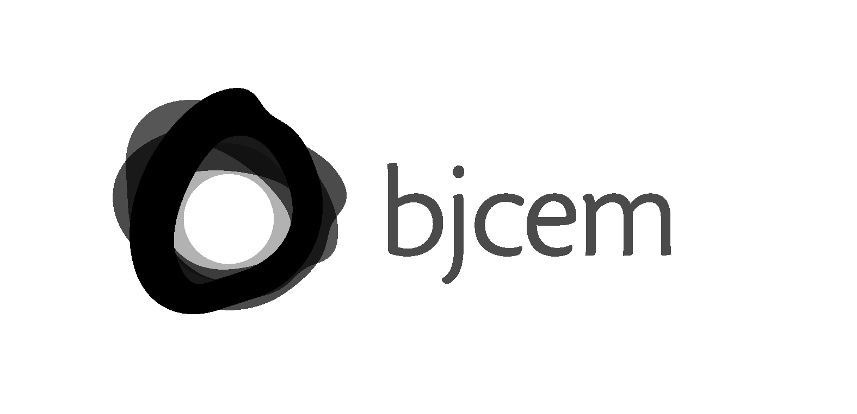

in collaboration with
promoted by
with the support of the
Youth in Action Programme of the European Union


RESET
10

APPLICATION FORM – sheet 1 (THE ARTIST)
////////////////////////////////////////////////////////////////////////////////////////////////////////////////////////////////////

PERSONAL DETAILS

FIRST NAME:

SURNAME:

DATE OF BIRTH:

PLACE OF BIRTH:

COUNTRY OF BIRTH (IF OTHER THAN ITALY):

NATIONALITY:

RESIDENCE:

STREET: N°:
POST CODE: TOWN: PROVINCE:

COUNTRY OF RESIDENCE (IF OTHER THAN ITALY)

DOMICILE (IF DIFFERENT FROM RESIDENCE)

STREET: N°:
POST CODE: TOWN: PROVINCE:

COUNTRY OF RESIDENCE (IF OTHER THAN ITALY)

TEL: MOBILE:
E-MAIL: WEB SITE:

ARTISTIC TRAINING (LIST STUDIES AND ARTISTIC QUALIFICATIONS):

BRIEF BIOGRAPHY OF ARTIST (350 CHARACTERS MAX, TO BE INCLUDED IN THE CATALOGUE):

EXHIBITIONS (MAX 3 OF THE MOST SIGNIFICANT EXHIBITIONS)TO BE INCLUDED IN THE CATALOGUE

I AM A RESIDENT OF THE PROVINCE OF TRIESTE OR GORIZIA AND WISH TO SUBSCRIBE TO THE GAI ARCHIVE IN TRIESTE

YES NO

INSTRUCTIONS FOR RETURNING OF THE ARTWORK:

- I WILL COLLECT MY ARTWORK IN PERSON OR HAVE IT COLLECTED BY AN AUTHORISED PERSON
- I WILL COLLECT MY ARTWORK BY SENDING A COURIER AT MY OWN EXPENSE

ARTEFATTO 10 - RESET

APPLICATION FORM – sheet 2 (THE WORK)
////////////////////////////////////////////////////////////////////////////////////////////////////////////////////////////////////

WORK DETAILS:

TITLE OF WORK:

YEAR MADE:

MEDIUM USED:

SIZE OR DURATION:

BRIEF COMMENT ON WORK (350 CHARACTERS MAX, INCLUDING SPACES, TO BE USED AS CAPTION AND ON CATALOGUE):

ANY NOTES REGARDING MATERIALS USED AND SET UP INSTRUCTIONS:

///////////////////////////////////////////////////////////////////////////////////////////////////////////////////////////////////

FOR PARTECIPATION SEND NO LATER THAN JANUARY 18, 2015 to questions@artefatto.info (not to exceed the limit of 20 Mb) THE ATTACHEMENTS AS FOLLOW:

a) the application form filled, signed and sent (in .pdf fomat)
b) copy of ID card or Passport
c) images or video of the work
- images in .jpg format (1200 pixel – horizontal and 900 pixel - vertical)
- videos in .mov or .avi format (if necessary use a file sharing)

////////////////////////////////////////////////////////////////////////////////////////////////////////////////////////////////

I agree to abide by the regulations governing the event and hereby authorise the printing, publication and exhibition of pictures of the artwork free of charge. I also authorise the processing of personal details for uses permitted by the law (Art. 7, Legislative Decree 196/2003 Privacy).

SIGNED BY ARTIST

……………………………………………………………………………………………..

///////////////////////////////////////////////////////////////////////////////////////////////////////////////////////////////////

The call for participation and application forms can be downloaded from:
www.artefatto.info
www.retecivica.trieste.it

INFO

Poli di Aggregazione Giovanile del Comune di Trieste
Piazza della Cattedrale 4/a - 34121 Trieste, Italy
tel. +39 040 348 5818 - e-mail: questions@artefatto.info

This project has been funded with the European Commission. This publication (communication) reflects the views only of the author, and the Commission cannot be held responsible for any use which may be made of the information contained therein.

